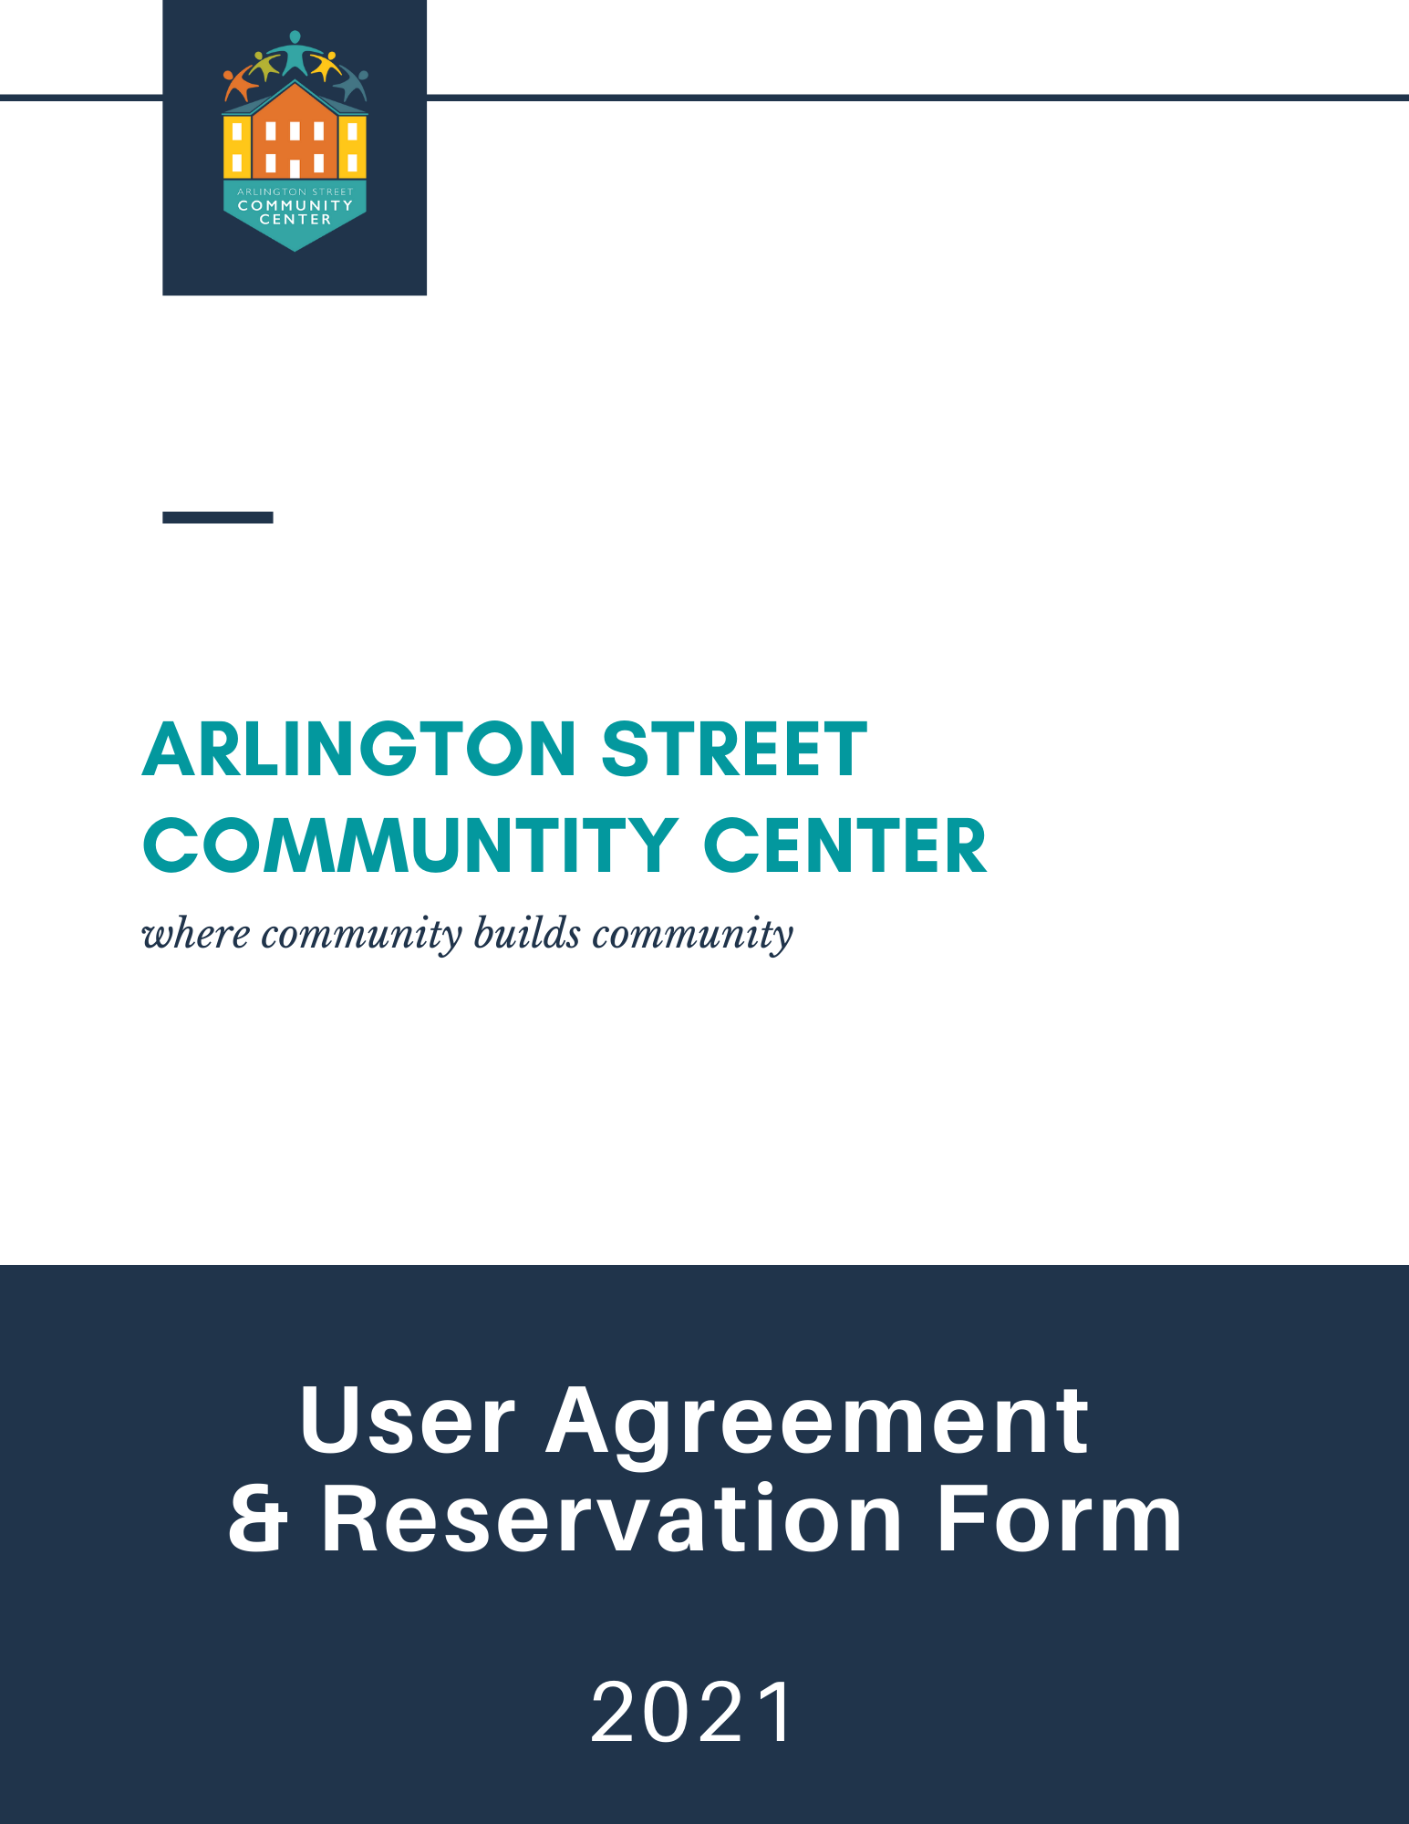

RESERVATIONS
All reservations for public meeting rooms are coordinated through the ASCC Director.
Jessica Hägg, ASCC Director
haggj@nashuanh.gov
(603) 204-5303

The Arlington Street Community Center is a welcoming, affirming, and safe space for all. The ASCC desires to make facilities available for civic, cultural, educational, recreational and other activities as long as these activities do not conflict with public purposes and activities, state and federal laws, local ordinances, or proper care and maintenance of the facility. Use of facilities will be granted in the following prioritized order:
1. Use by the City of Nashua, including organizations partnering with the center for community programming
2. Use by the Nashua School District and their affiliates
3. Use by city and local nonprofits
5. Use by private businesses, organizations, or for-profit agencies

Each user must complete a reservation packet and submit it to the ASCC Director. The user is responsible for timely payment (see pg. 2). Payments must be received at least fourteen (14) days prior to the reservation date. The director will only accept complete reservation packets which consist of the following:
  - User Agreement
  - Reservation Form
  - Access Control Form (if applicable)
  - Request for Proposal (if applicable)
- Reservations will be confirmed and placed on the calendar pending approval after receipt of a completed and signed user agreement, reservation form, and a refundable deposit (if required).

- Resume, credentials, proof of insurance, and background checks may be required for activities such as classes and must be submitted with this request form if needed.
- Cancellation of a reservation must be communicated no less than 72 hours in advance. Refunds in excess of the refundable deposit will only be made if 72 hours advance notice was received. Failure to cancel or appear for a reservation may result in denial of future reservations. If a user owes outstanding payments for prior use, no further reservations will be approved until all outstanding balances are paid in full.
- If a reservation needs to be rescheduled, the sponsoring organization or user is responsible for contacting the ASCC Director on the next day of operation. If a satisfactory time is not available, all payments will be refunded.
- Users wishing to reserve the ASCC may be required, at the discretion of the Director, to hire security for scheduled events. Any security requirements will be stipulated at the time the reservation is confirmed. Satisfactory proof will be required before the use of ASCC is allowed. Failure to provide required security will be regarded as a late cancellation and will lead to all applicable charges for the reservation.

user payments
All payments collected for use of the Arlington Street Community Center are considered donations and will be used to offset building costs and associated costs of the activities, in addition to funding new programming that aligns with the center’s mission.
Groups are designated in the following donation categories:
Group A: Recognized groups affiliated with the City of Nashua.
Group B: Nonprofits and all other groups classified under Section 501 (c)3 of the IRS tax code.
Group C: Groups acting as nonprofits serving the community but without the designation of 501(c)3 status.
Group D: For-profit groups (private dance schools, theater groups, camps, etc.)
Group E: Private events.

Group | Meeting Rooms  (A or B) | 3rd Floor  (Dance Studio) | Deposit
Group A | - | - | -
Group B | $15.00 | $40.00 | $100.00
Group C | $20.00 | $50.00 | $100.00
Group D* | $40.00 | $70.00 | $100.00
Group E* | $30.00 | $50.00 | $100.00

*requires proof of insurance. (see pg. 3)

- Payment in the form of checks or cash are to be made payable to the City of Nashua – ASCC with Donation: (insert date of event) written in the memo line. If paying by check, two separate checks must be submitted: one check for the $100 deposit and one check for the associated payment. Payments must be paid at least 14 days in advance of event.

- The payment for Groups B, C, D, and E may be amended at the discretion of the ASCC Director to a percentage of gross revenue provided in the estimation of the ASCC Director or to a set dollar amount per attendee to cover reasonable costs of facility.

- Payment for blocks of classes, events, or programs are determined by the ASCC director and may vary from the guide above given the event or program.

hours of operation
Monday-Friday: 9 AM - 8 PM
Saturday-Sunday: as scheduled or reserved.

*Hours are subject to change and may be altered by special arrangement.

INSURANCE
The City of Nashua requires that all users hosting an event on City of Nashua property provide proof of insurance, naming the City of Nashua as insured. Event insurance can be purchased at: https://gatherguard.com/
requirements

- COI should identify the event being held, along with dates of event.

- Certificate holder should be listed as:

City of Nashua,
229 Main Street
Nashua, NH 03060

- Coverage must be written with an insurance carrier licensed to do business in the State of New Hampshire.

- Any and all companies/vendors hired by the event holder are the agents of the event holder and NOT the City of Nashua. Companies/vendors hired are subject to the same insurance requirements as the event holder.

- Failure to meet all insurance requirements shall constitute a default of the ASCC User Agreement and may result in the immediate termination of the agreement.

CONDITIONS FOR USE

setup and breakdown
- When reserving the ASCC, the user should specify the number of individuals expected; the number cannot exceed the maximum capacity stated by law. The total capacity of the Community Center is 275 people: Room A & B = 75 each; dance studio = 125.
- Chairs and tables are provided in the meeting rooms. The user will be responsible for returning the room to its pre-event condition. Furniture, equipment, or supplies from elsewhere in the building may not be used unless previously authorized.
- Additional chairs and tables may be requested prior to the event; otherwise, the spaces are rented “as is.”
- It is the responsibility of the user to set up and break down tables, chairs, and other equipment used and leave the room in the setup it arranged before the rental.
- Users are not permitted to occupy rooms other than what was originally requested. Users are responsible to ensure guests are using appropriate rooms.
- Users and their guests are not permitted to go downstairs in the office area.
- Users will ultimately be held liable for any damages or accidents incurred during the granted rental time. All event setup, breakdown, and cleanup must be completed within the time specified on the reservation form.
- The refundable deposit will be returned upon review of the facility.
- Approved users will be given an access card if necessary. The card will be programmed to allow entrance to the ASCC one hour before and one hour after the total requested time. Cards must be returned to the ASCC Director after the event as concluded; deposits will not be returned until the access card has been turned in.

cleaning and maintenance

- The user shall keep the premises in a clean condition; all surfaces must be wiped down and floors must be swept/vaccumed and mopped if necessary. Cleaning supplies are kept in the back closet adjacent to the side entrance.
- All trash barrels used must be emptied and re-lined. Trash can be disposed of in the blue barrels in side alleyway between the center and the garage.
- The user shall not permit the premises to be overloaded, damaged, stripped, or defaced.
- Users are prohibited from mounting anything on walls or other surfaces without prior permission from the ASCC Director.
- Users serving food and beverages are responsible for providing food, beverages, and any other napkins or cutlery. The use of alcohol is strictly prohibited in or on the premises of the ASCC.

regulations

- As regulated by state law, smoking is prohibited in or on the premises of the ASCC.
- The use of alcohol is strictly prohibited in or on the premises of the ASCC.

- Per Fire Department regulations, no open flames are permitted in or on the premises of the ASCC.
- Use of the ASCC for the conduct of illegal activity is strictly forbidden and will result in immediate loss of privileges.
- Individuals ages 20 and under may not reserve the ASCC and attendees ages 20 and under must be supervised by the user.
- Reservation of the ASCC is not transferable.
- The ASCC Director reserves the right to terminate a function at any time due to inappropriate activity or behavior.
- Any local or state licenses, permits, or fees are the responsibility of the user. The ASCC Director may request review of any documents prior to the event.
- The user shall be responsible for the safe storage of their furnishings, equipment, and possessions.
- No copies of access cards or keys shall be made without the permission from the ASCC Director.
- Access cards are to only be used by the authorized user listed on the reservation forms.
- Reservations will not be approved to users that have previously failed to comply with stated conditions for use. This includes, but is not limited to, failure to allow staff to follow normal closing procedures, excessive noise leading to complaints by other users, inappropriate use of facility property, or failure to clean up after an event.

facilities and maintenance

- Parking is permitted in the front of the building and along Arlington Street as marked. There is no parking on Bowers Street.
- The ASCC is handicap accessible on the first floor; the third floor dance studio is not.
- The front or side door is not to be propped open at any time.
- Windows must remain closed.
- Fire extinguishers are located in each major room, hallway, and stairwell. Exit signs are located at each exterior door and in each hallway. Exit lighting is located outside of each exterior door.
- In the case of an emergency, call 911.

ARLINGTON STREET COMMUNITY CENTER
RESERVATION FORM

Please visit the Arlington Street Community Center calendar at www.asccnashua.com
for room availability prior to submitting your application. Open dates are not a guarantee, as some applications may be in process.

Name: Click or tap here to enter text. Organization: Click or tap here to enter text.
Phone #: Click or tap here to enter text. Email: Click or tap here to enter text.

Event: Click or tap here to enter text.
Please select a category:
City of Nashua Nonprofit/Civic Org. For-profit Group/Business Private Event
Number of People: Click or tap here to enter text.
Date of Event: Click or tap to enter a date.
Recurring or Multiple Dates? Yes No
If yes:
Start Date: Click or tap to enter a date. End Date: Click or tap to enter a date.
Day of Week: Choose an item. Frequency: Choose an item.
List all dates here: Click or tap here to enter text.

Total Time Requested (including set-up and clean-up time): Choose an item. - Choose an item.
Actual Event Time: Choose an item.
Room(s) Requested: Room A Room B 3rd Floor Dance Studio Entire Building
Will food and/or beverages be served at this event?
Yes No If yes, please describe: Click or tap here to enter text.

Equipment needed (check all that apply and indicate the number of each item needed):

Tables #
Chairs #
White Board #
Projector (indicate PC or Mac) #
Easel #
Extension Cord #
Other Click or tap here to enter text.
Note: Arrangements must be made to use tables, chairs, or any other equipment not currently available in each room. Specific conditions may apply to the agreement per the discretion of the ASCC Director.

Payment:
Set amount of $ for the event or entire block of events
Set amount of $ per attendee per class or event
% of gross revenue from event
Other

Office use only:
Payment Received Security Deposit Received Payment Waived
Proof of Insurance Resume/Credentials Provided Background Check Completed
Licenses/Permits Obtained
Notes:

ARLINGTON STREET COMMUNITY CENTER
USER AGREEMENT

Each user will faithfully observe, keep, and obey all terms and conditions of the permit, laws, rules and ordinances of the City of Nashua. The user will also faithfully observe, keep and obey all laws, rules and regulations of any other governmental entity including, State and federal regulations which may apply. Users are ultimately responsible for the actions of their guests.
The users act on behalf of and represents their organization. The user will save and protect, hold harmless, indemnify and defend the City, its commissions, officers, agents, and employees against any and all liability, causes of action, claims, loss, damages, or cost and expenses arising from, allegedly arising from, or resulting directly or indirectly from any acts of the users or any of its officers, employees, guests, or agents done in the performance or operations of the event, or any act done under pretended authority.
This agreement to indemnify and hold the City harmless shall include any costs incurred by the City in defending any action involving an act by the user or any of its officers, employees, guests, or agents, and shall include attorney’s fees incurred by the City.
I further agree to protect, save, and keep the City of Nashua, the Arlington Street Community Center, their agents, and their employees forever free and harmless and indemnified against and from any and all loss, cost, or expense arising out of or from any accident or other occurrence causing injury to any person or property whomsoever or whatsoever as a result of the use of the above premises.
I certify that I am the person requesting the room or am an officer of the above-named organization; that, if part of an organization, I have the authority to reserve the Arlington Street Community Center; and that the above statements are true to the best of my knowledge and belief.
I hereby agree that the user will be responsible for any damage caused by the user or user’s guests to the Arlington Street Community Center premises and furnishings because of the use of said premises by the above user, and agree to pay for said damages assessed by the City of Nashua.
I have received, read, and agree to abide by and uphold all rules and policies governing the use of the Arlington Street Community Center. I also agree to release, acquit, discharge the City of Nashua for any and all claims or rights of action for any personal injuries or property damage which may occur as a result from the use of the above premises.

Name (Print): Click or tap here to enter text. Date: Click or tap to enter a date.
Organization: Click or tap here to enter text. Signature: X Click or tap here to enter text.

